Civic Contribution Guidelines
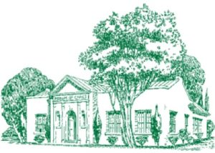
Civic Contribution Guidelines 2025-2026
The Civic Contributions Committee will begin receiving requests on Monday, June 2, 2025.
All requests must be submitted by
Wednesday, October 15, 2025.
Requests received after this deadline will not be considered.
Funding will be awarded to the committee’s recipients in the first quarter of 2026.

The Guidelines for eligible 501 (c) (3) organizations are as follows:
- We support local landscape and beautification projects, horticulture awareness, conservation, and educational projects related to horticulture or conservation. Funds are to be spent and accounted for within the year of receipt of said funds, unless otherwise specified.
- Requests must be in writing and accompanied by a copy of the organization’s tax exemption letter.
- Priority consideration is given to eligible requests from the Houston area.
- Private educational institutions may be considered.
- Church organizations are not eligible.
For questions regarding the request form, please email chairman
Molly Vaughan mollygvaughan@gmail.com

Civic Contributions Committee 2025-2026
Molly Vaughan, Chairman
Laura Sheffield, Assistant Chairman
Sharon McNearney
Pam Ott
Carol Ann Paddock
Stacy Wilkirson

